Single Transaction

Definition
# Source: AI Source: Provided by: [Data Path: Persons Table -> ID Column: 1, Name_En Column: Motasem Essam] -> From: [Chatgpt (GPT‑5 Mini)] on [12/10/2025]
A Single Transaction is a set of operations that are treated as one complete unit of work within a system.
- All operations in the transaction must succeed for it to be saved.
- If any operation fails, the entire transaction is cancelled (rolled back).
Key idea:
A single transaction follows the “all or nothing” rule.

How Single Transactions Work
# Source: AI Source: Provided by: [Data Path: Persons Table -> ID Column: 1, Name_En Column: Motasem Essam] -> From: [Chatgpt (GPT‑5 Mini)] on [12/10/2025]
- Start the transaction
- Perform a series of operations
- Check for errors during execution
- If all operations succeed → Commit (save changes)
- If any operation fails → Rollback (undo all changes)

Example
# Source: AI Source: Provided by: [Data Path: Persons Table -> ID Column: 1, Name_En Column: Motasem Essam] -> From: [Chatgpt (GPT‑5 Mini)] on [12/10/2025]
Bank Transfer Example:
- Transfer $100 from Account A to Account B
Steps:
- Subtract $100 from Account A
- Add $100 to Account B
- If both steps succeed → transaction is committed
- If adding to Account B fails → subtraction is undone

Database Example
# Source: AI Source: Provided by: [Data Path: Persons Table -> ID Column: 1, Name_En Column: Motasem Essam] -> From: [Chatgpt (GPT‑5 Mini)] on [12/10/2025]
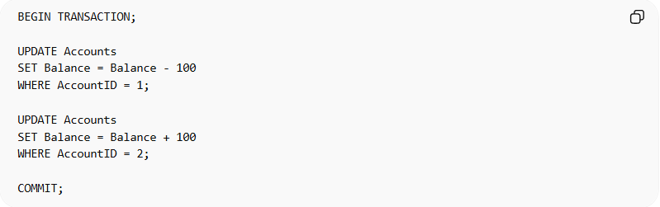
BEGIN TRANSACTION;

UPDATE Accounts
SET Balance = Balance - 100
WHERE AccountID = 1;

UPDATE Accounts
SET Balance = Balance + 100
WHERE AccountID = 2;

COMMIT;
- If any error occurs before COMMIT → system will perform ROLLBACK
- This ensures data consistency

Key Characteristics
# Source: AI Source: Provided by: [Data Path: Persons Table -> ID Column: 1, Name_En Column: Motasem Essam] -> From: [Chatgpt (GPT‑5 Mini)] on [12/10/2025]
- Treated as a single unit of work
- Follows ACID properties
- Ensures all operations succeed or fail together
- Maintains data integrity
- Common in financial and critical systems

Advantages
# Source: AI Source: Provided by: [Data Path: Persons Table -> ID Column: 1, Name_En Column: Motasem Essam] -> From: [Chatgpt (GPT‑5 Mini)] on [12/10/2025]
- Ensures data accuracy
- Prevents partial updates
- Simple to understand and manage
- Reliable for critical operations
- Keeps database consistent

Disadvantages
# Source: AI Source: Provided by: [Data Path: Persons Table -> ID Column: 1, Name_En Column: Motasem Essam] -> From: [Chatgpt (GPT‑5 Mini)] on [12/10/2025]
- Can be inefficient if large operations fail and must be retried
- May lock resources during execution
- Can reduce system performance in heavy systems
- Not suitable for highly independent operations

Summary
# Source: AI Source: Provided by: [Data Path: Persons Table -> ID Column: 1, Name_En Column: Motasem Essam] -> From: [Chatgpt (GPT‑5 Mini)] on [12/10/2025]
Feature | Single Transaction
Nature | One complete unit of work
Rule | All operations must succeed
Failure Handling | Rollback everything
Benefit | Ensures data integrity and consistency

